TOUR OF HISTORIC CRANFORD - QR CODE MAP
Open the camera app on your home screen. Hold your device so that the QR code appears in the viewfinder in the camera app. Your device will recognize the QR code and show a notification. Tap the notification to open the audio description of the Cranford site associated with the QR code.

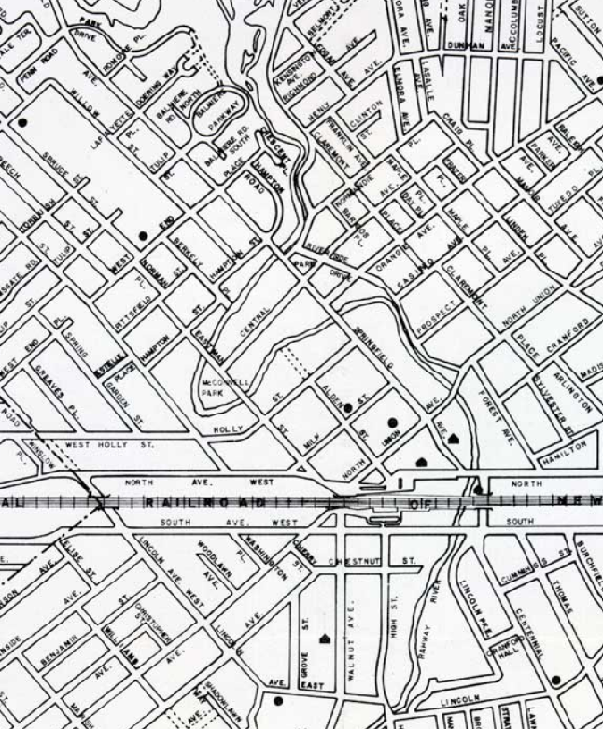
20
25
24
23
22
21
19
18
17
16
15
14
13
12
11
10
9
7
8
6
5
4
3
2
1
TOUR OF HISTORIC CRANFORD – LOCATIONS OF SITES AND QR CODES FOR MAP

Site # | QR Code | Cranford Historic Site Name
1 | 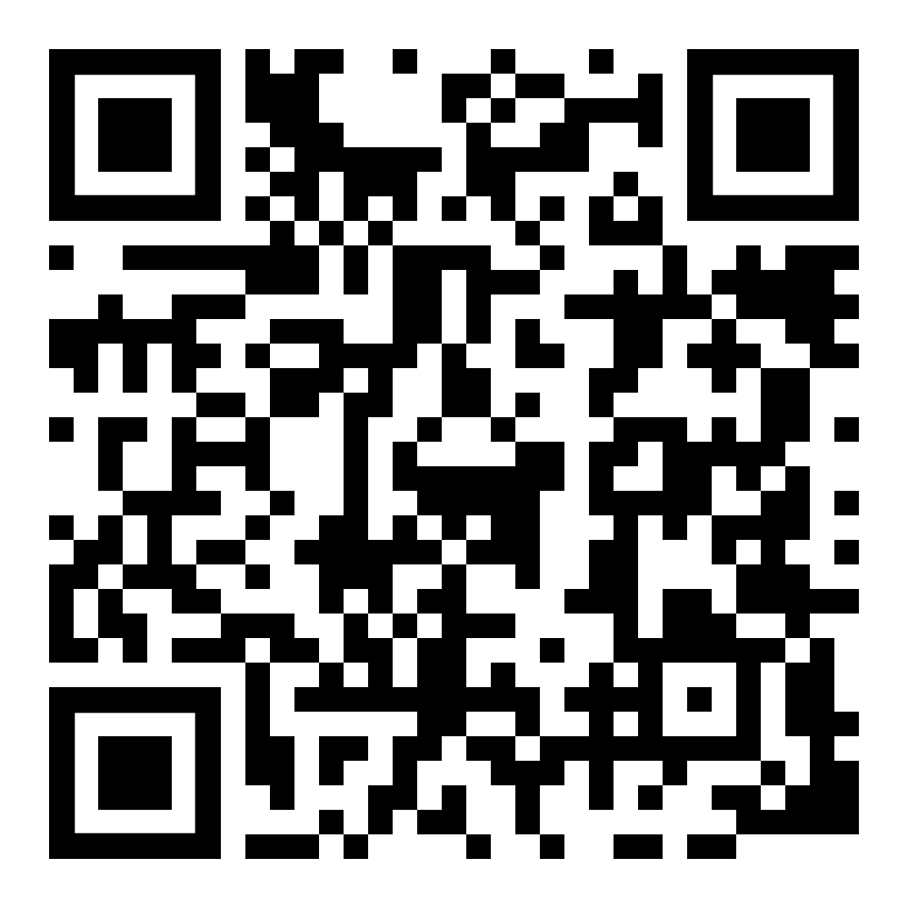 | Droesher's Mill (347 Lincoln Avenue E)
2 | 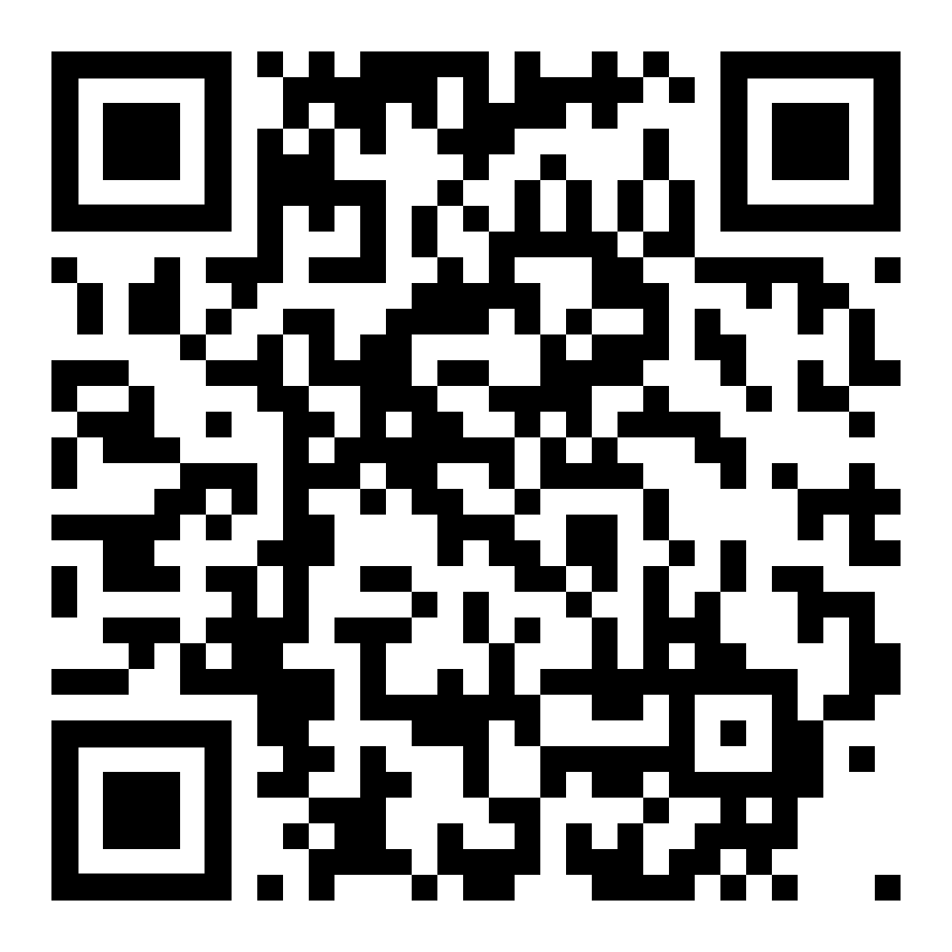 | Cranford Hall (600 Lincoln Park East)
3 | 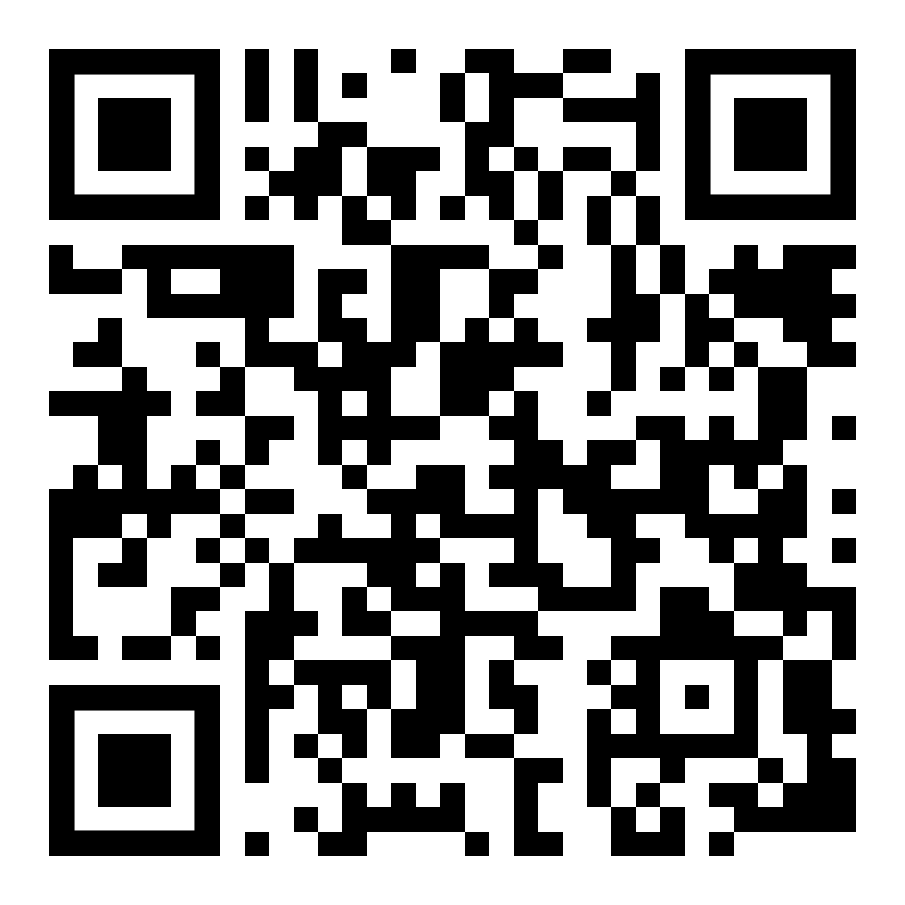 | Rahway RIver
4 | 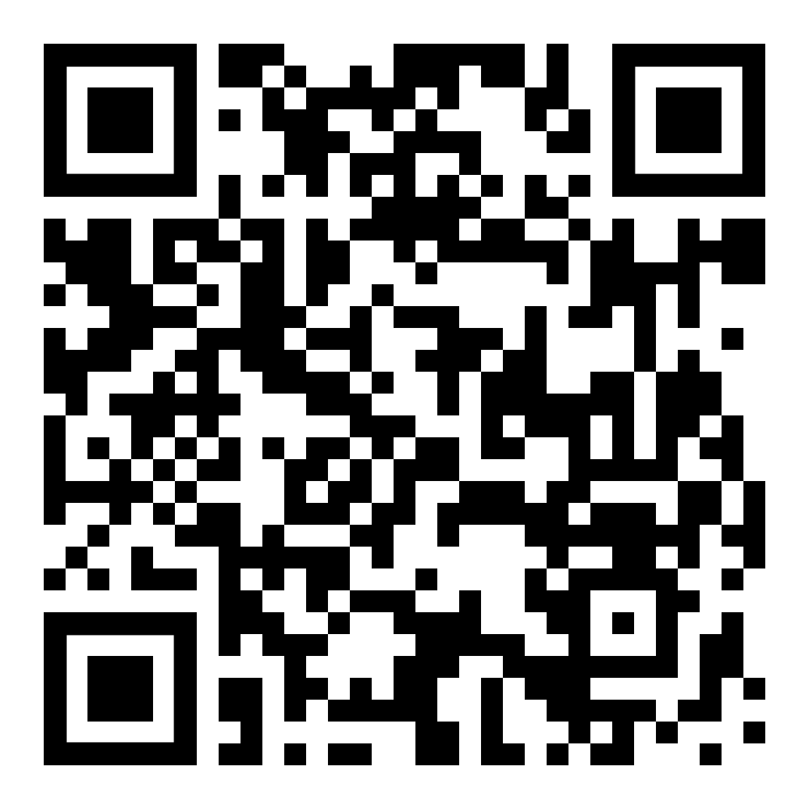 | First Baptist Church (100 High St)
5 | 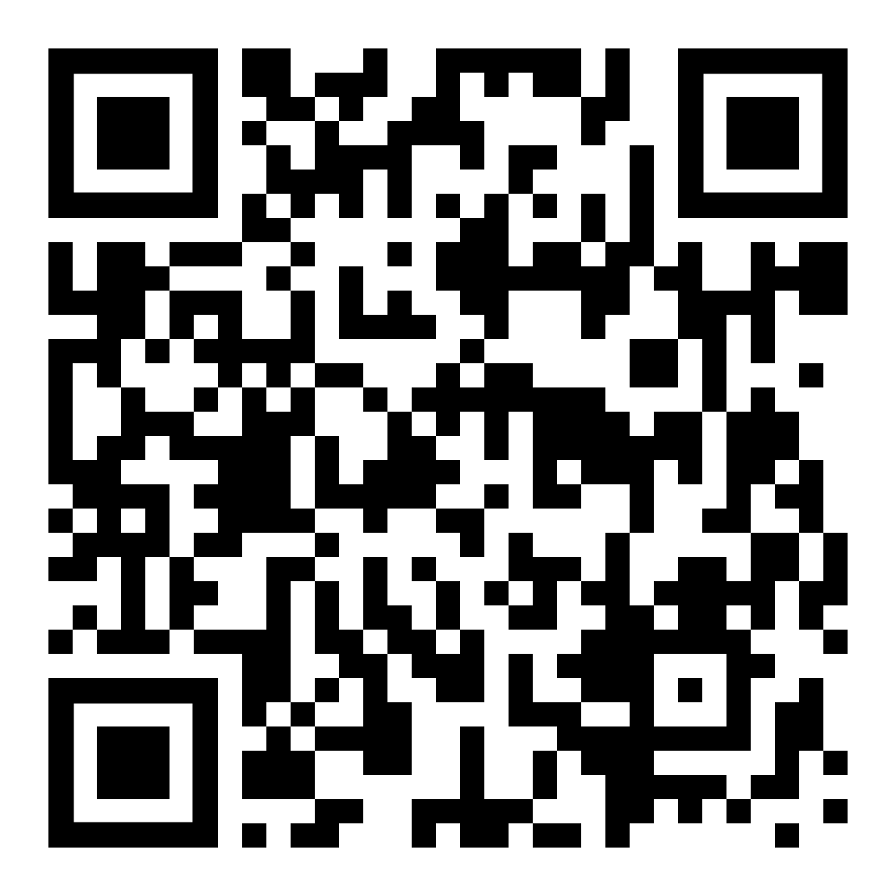 | Cranford Hotel (1 S Union Ave)
6 | 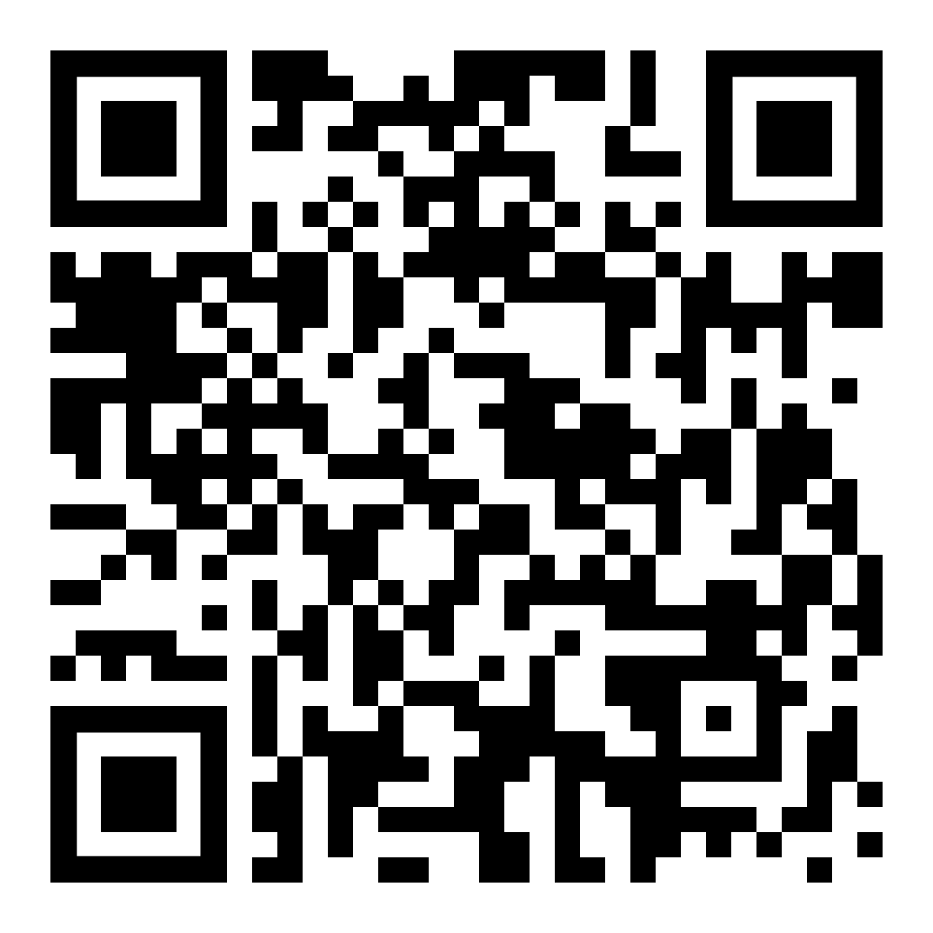 | Train Station (North Ave at Alden St)
7 | 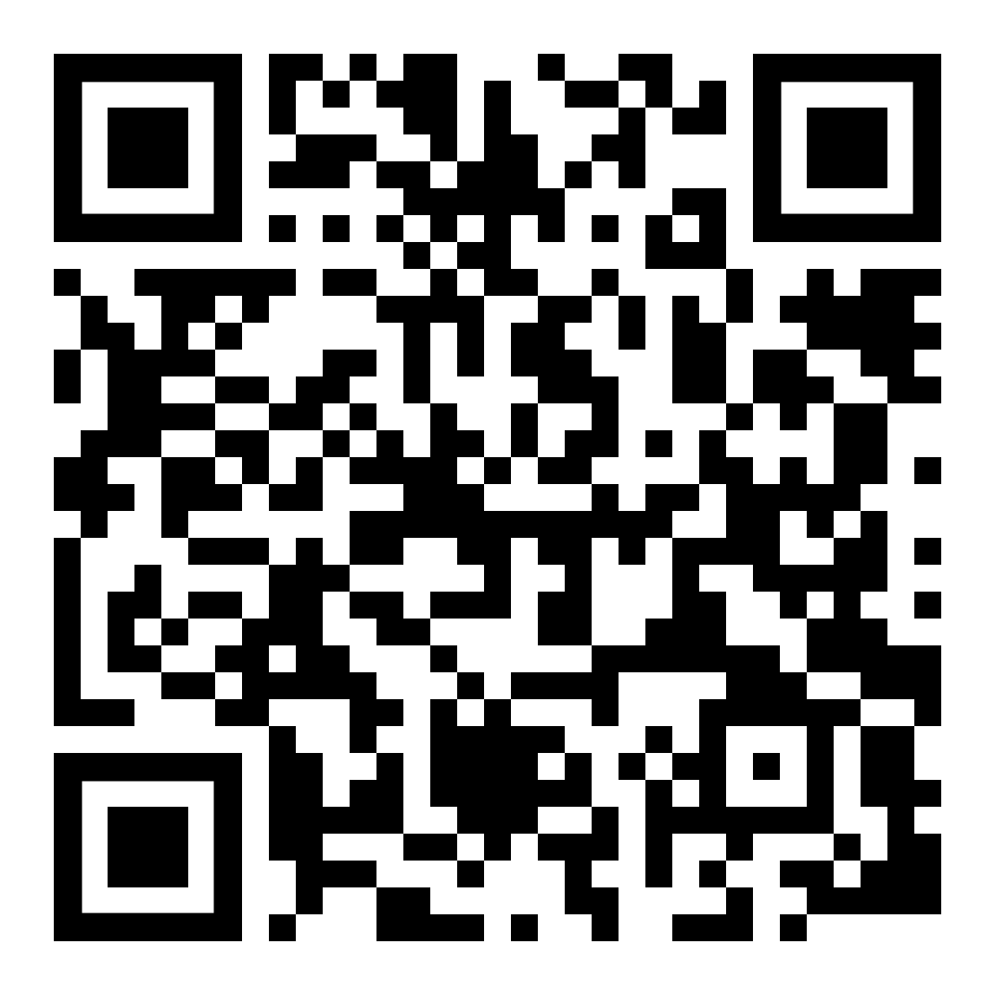 | Jahn Building (15-17 Eastman St)
8 | 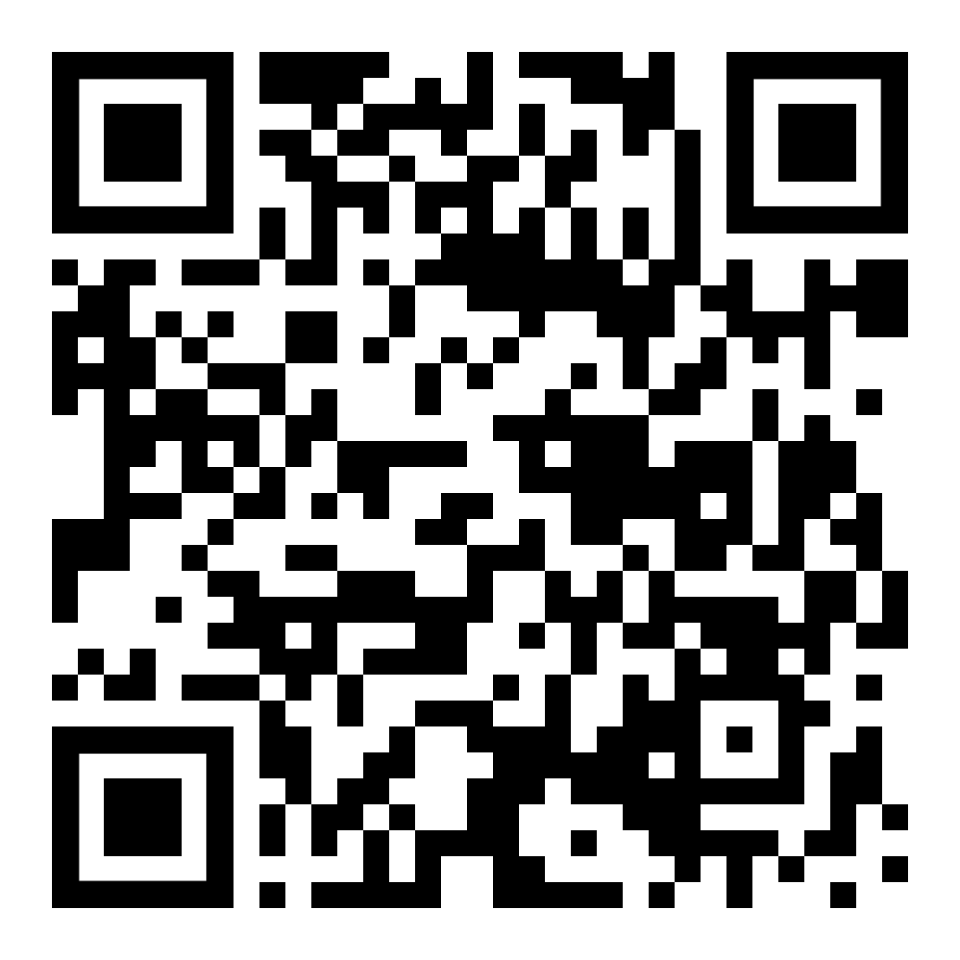 | Post Office (Miln St and Eastman St)
9 | 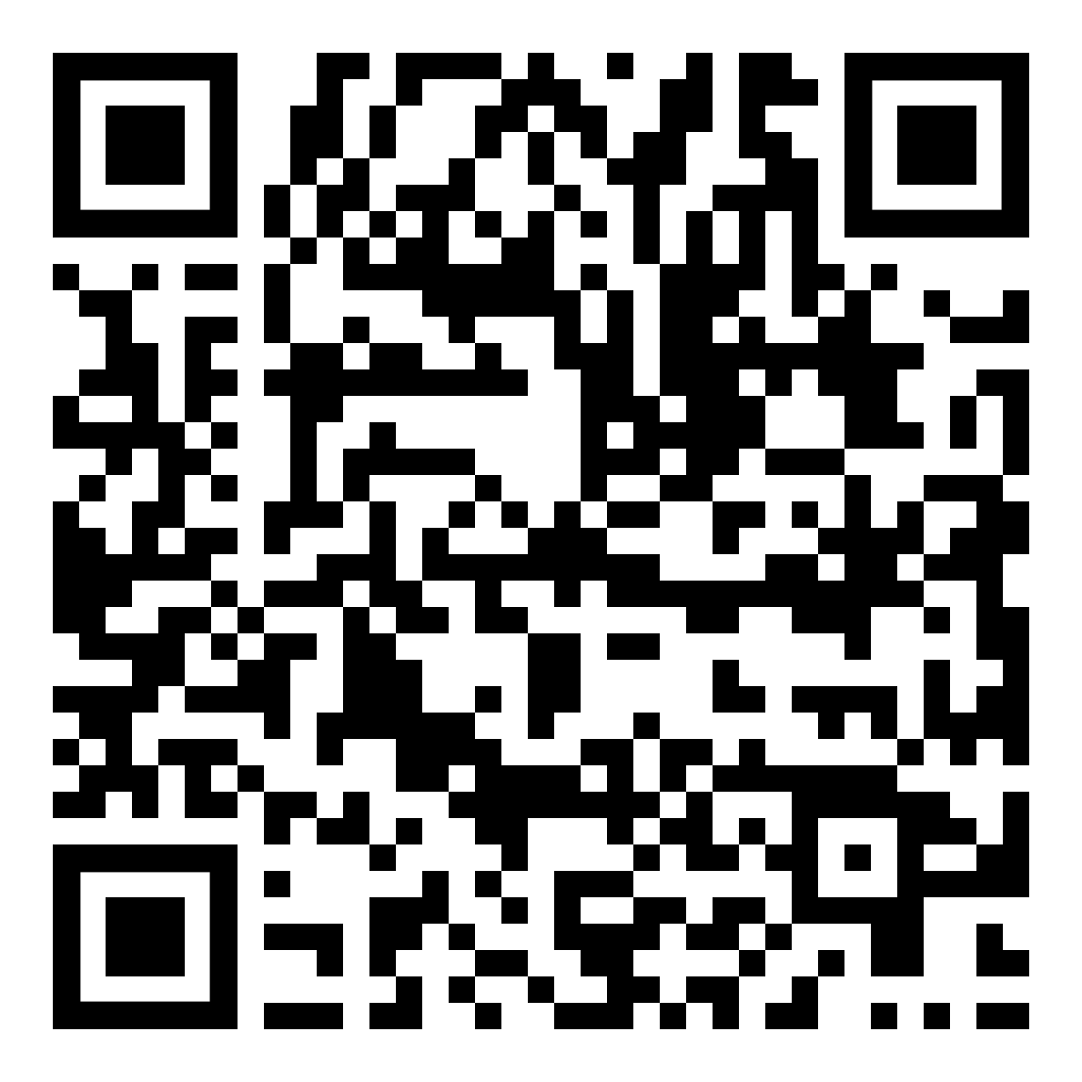 | Cranford Trust Building/Opera House Block (North Ave from Eastman St to N Union Ave)
10 | 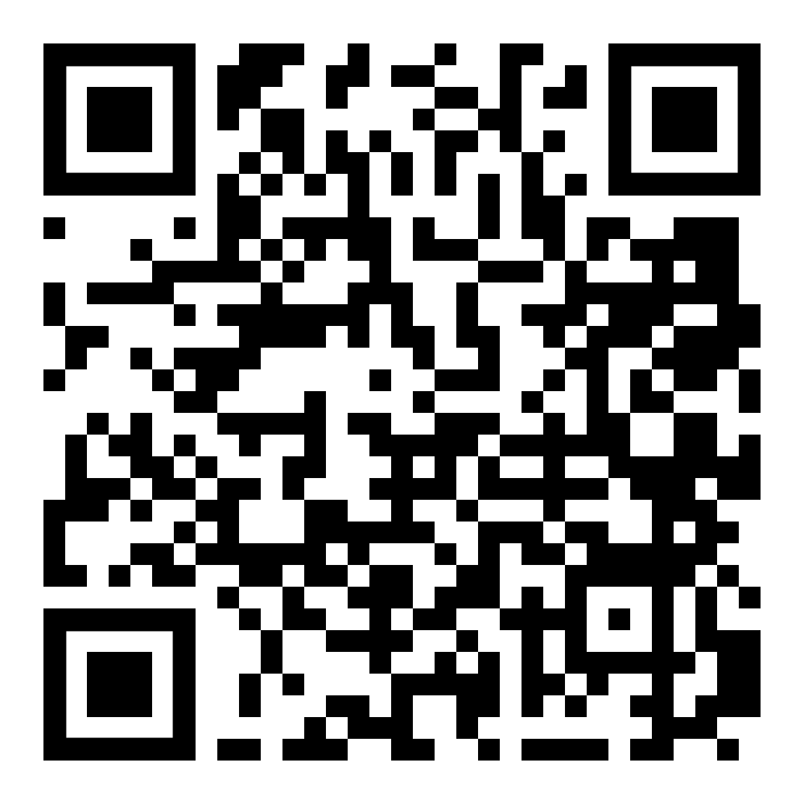 | Cranford Trust Building (North Ave at N Union Ave)
11 | 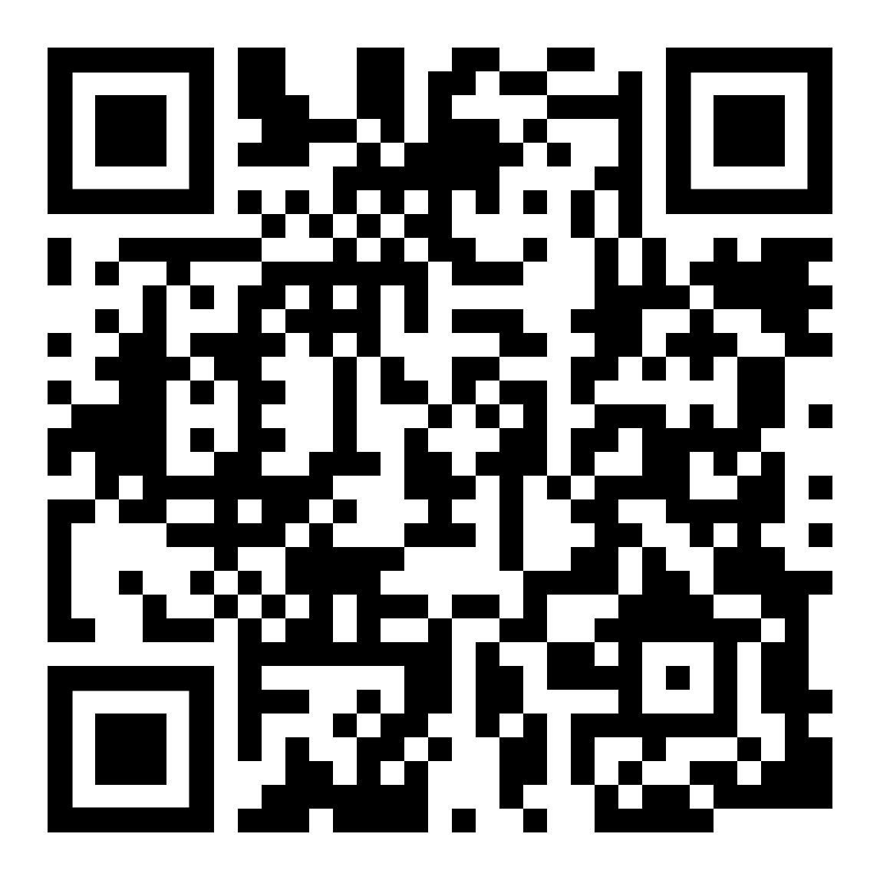 | Darsh Building (N Union Ave and Alden St)
12 | 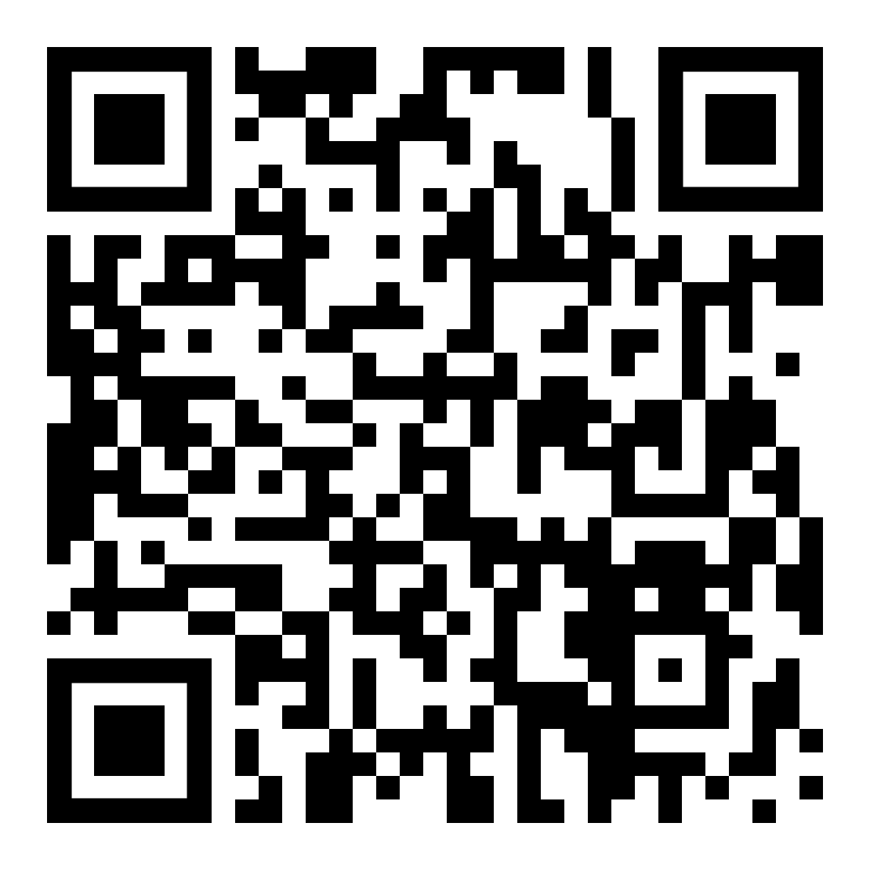 | Masonic Building (N Union Ave and Alden St)
13 | 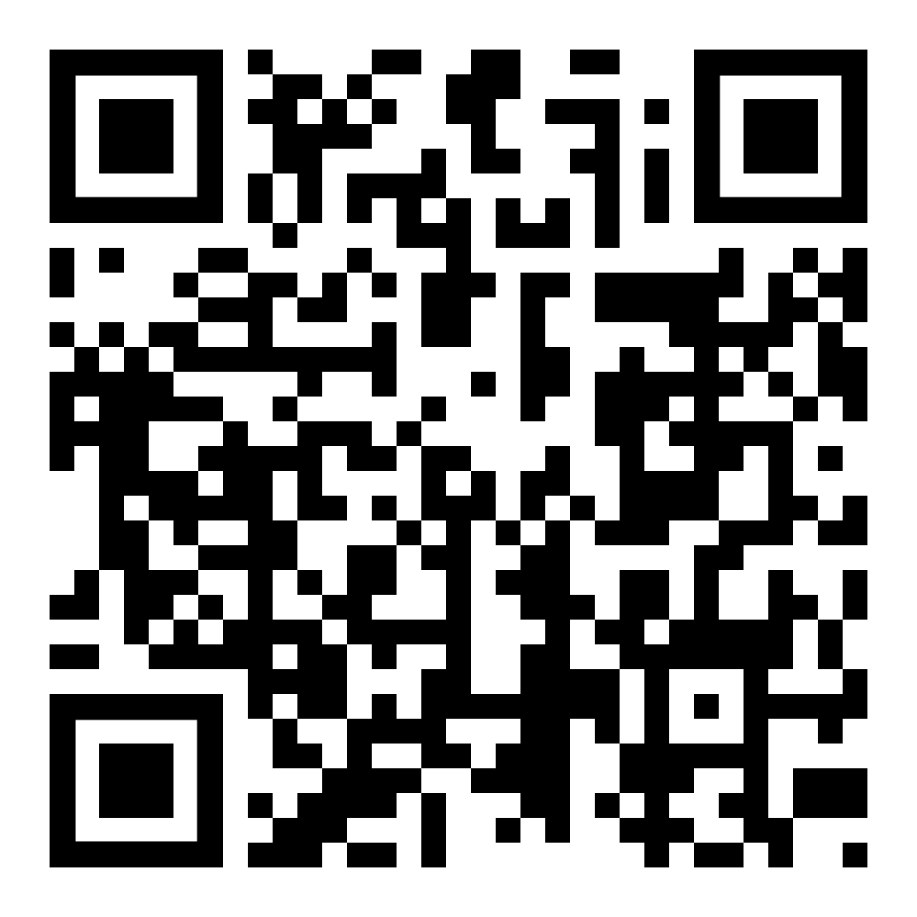 | Sperry Building (Alden St and North Ave)
Site # | QR Code | Cranford Historic Site Name
14 | 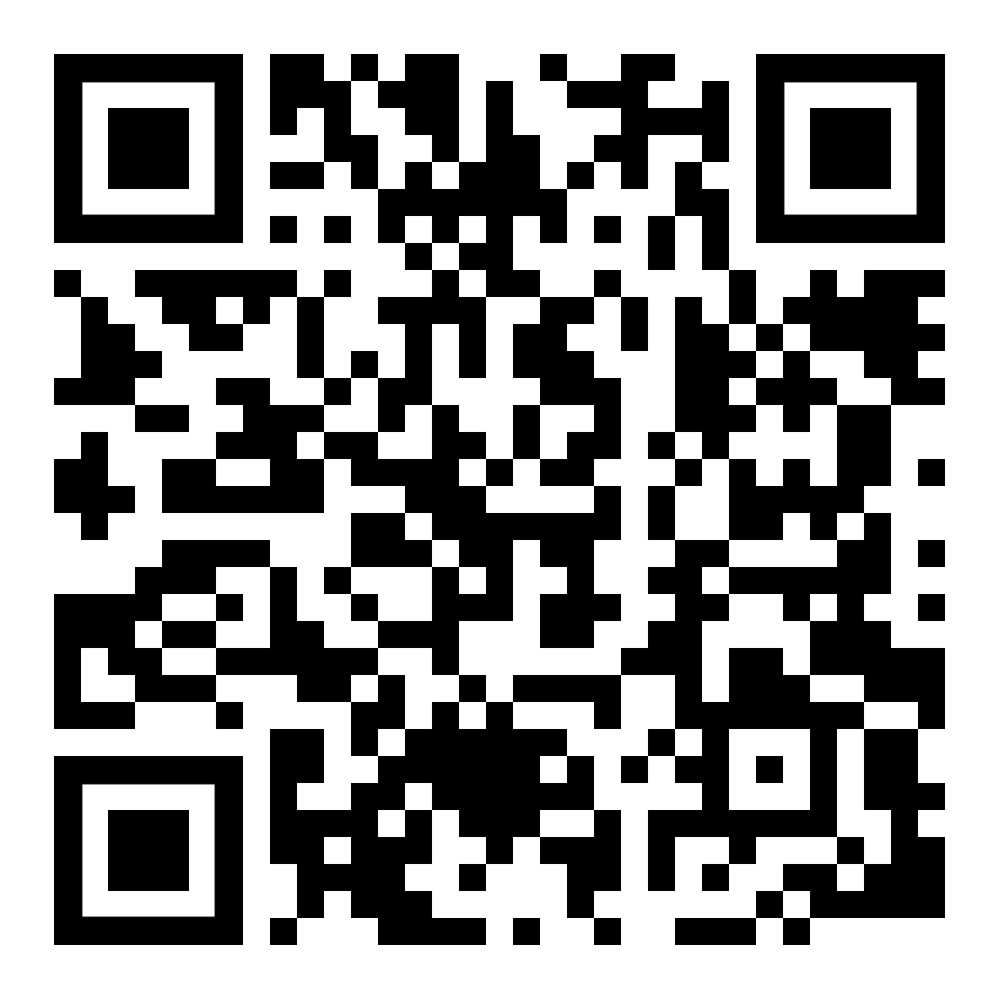 | Cleveland Plaza (123 N Union Ave)
15 | 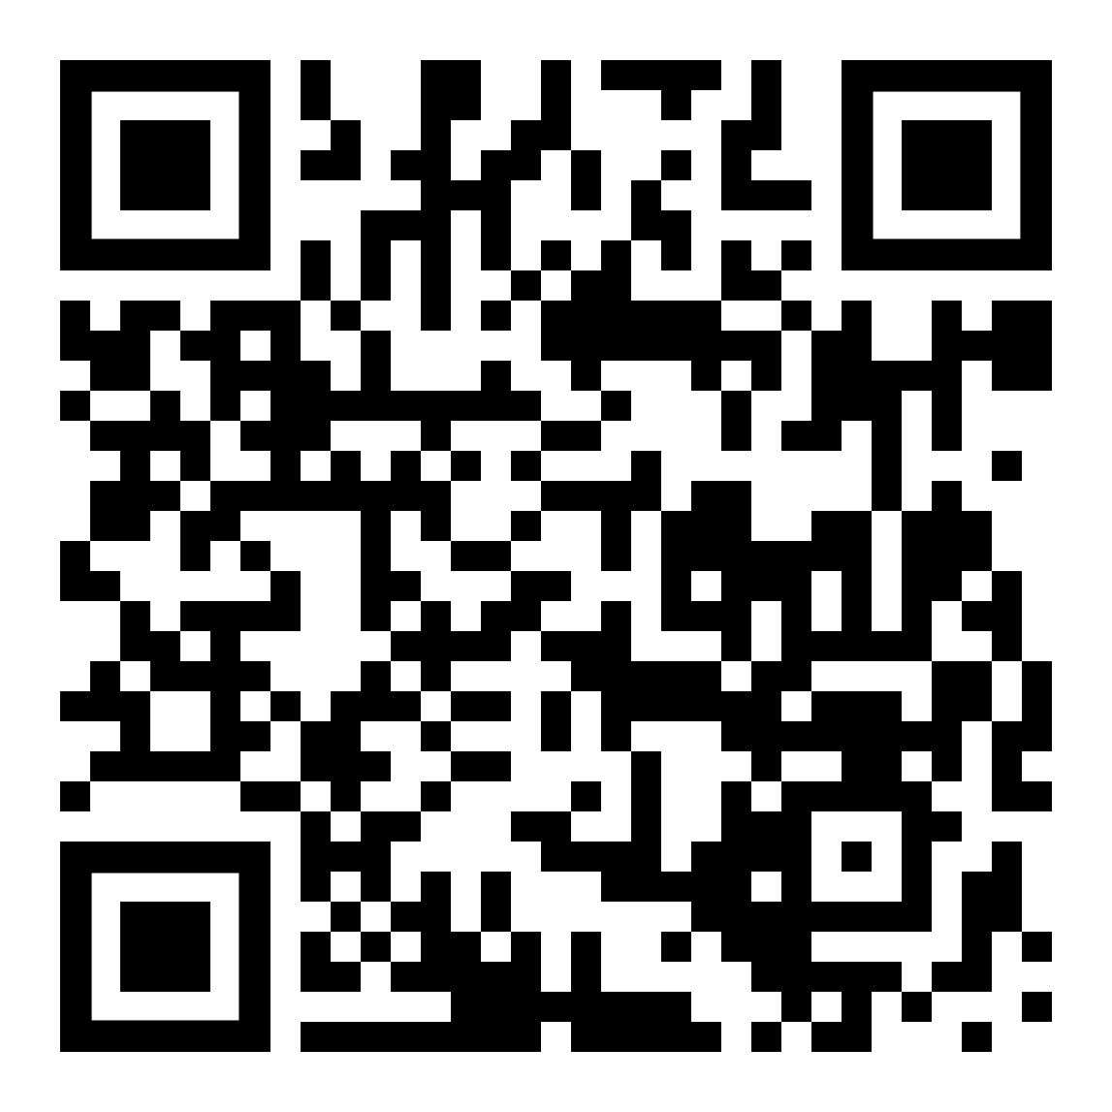 | First Presbyterian Church (N Union Ave and Springfield Ave)
16 | 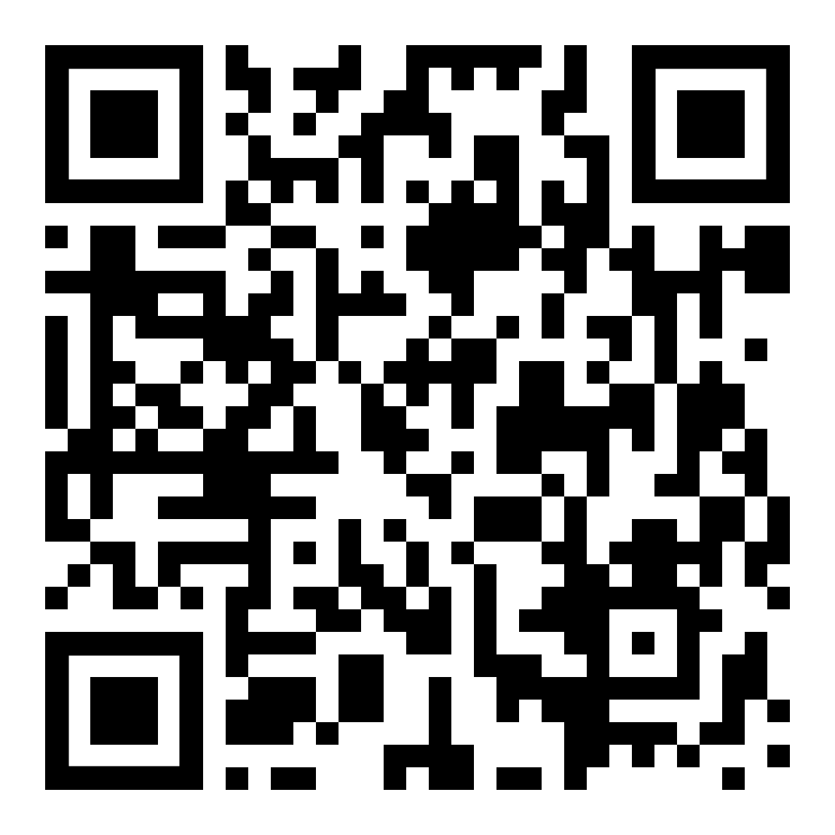 | Crane Phillips House (124 N Union Ave)
17 | 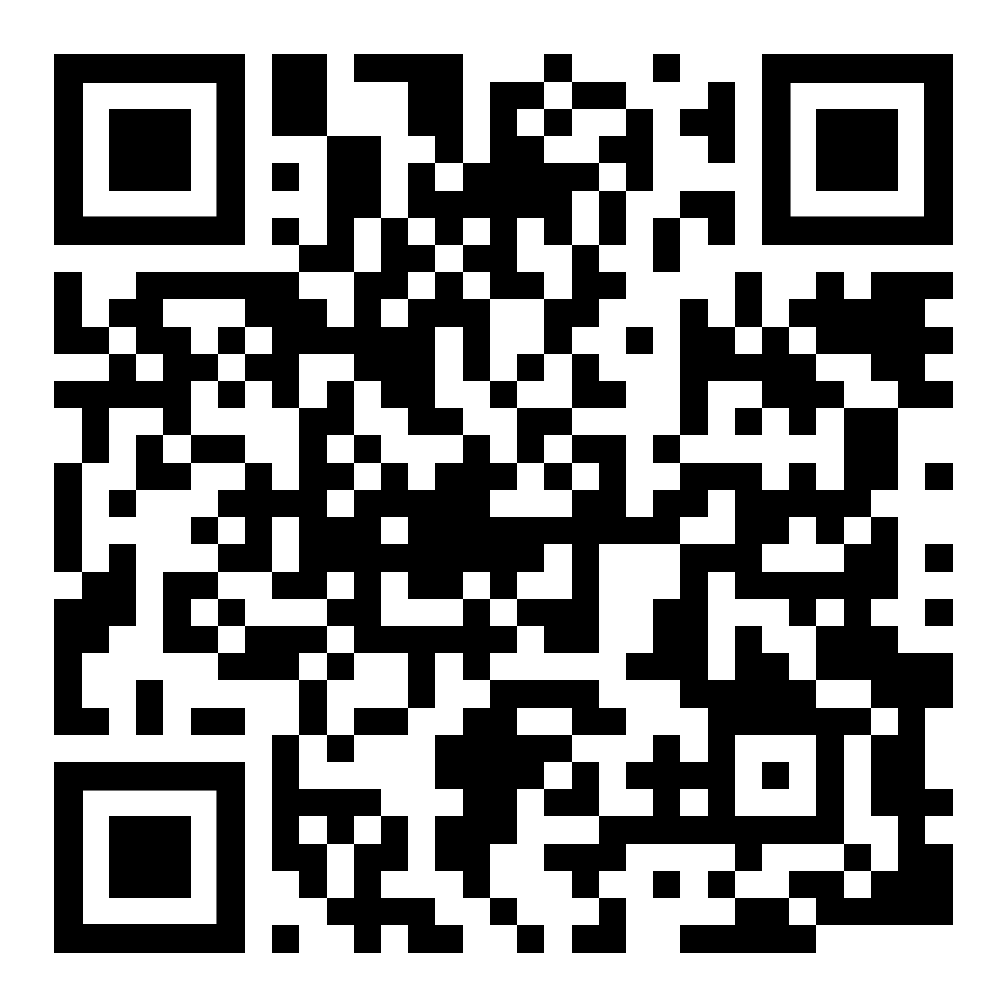 | Christian Science Building (Springfield Ave and Miln St)
18 | 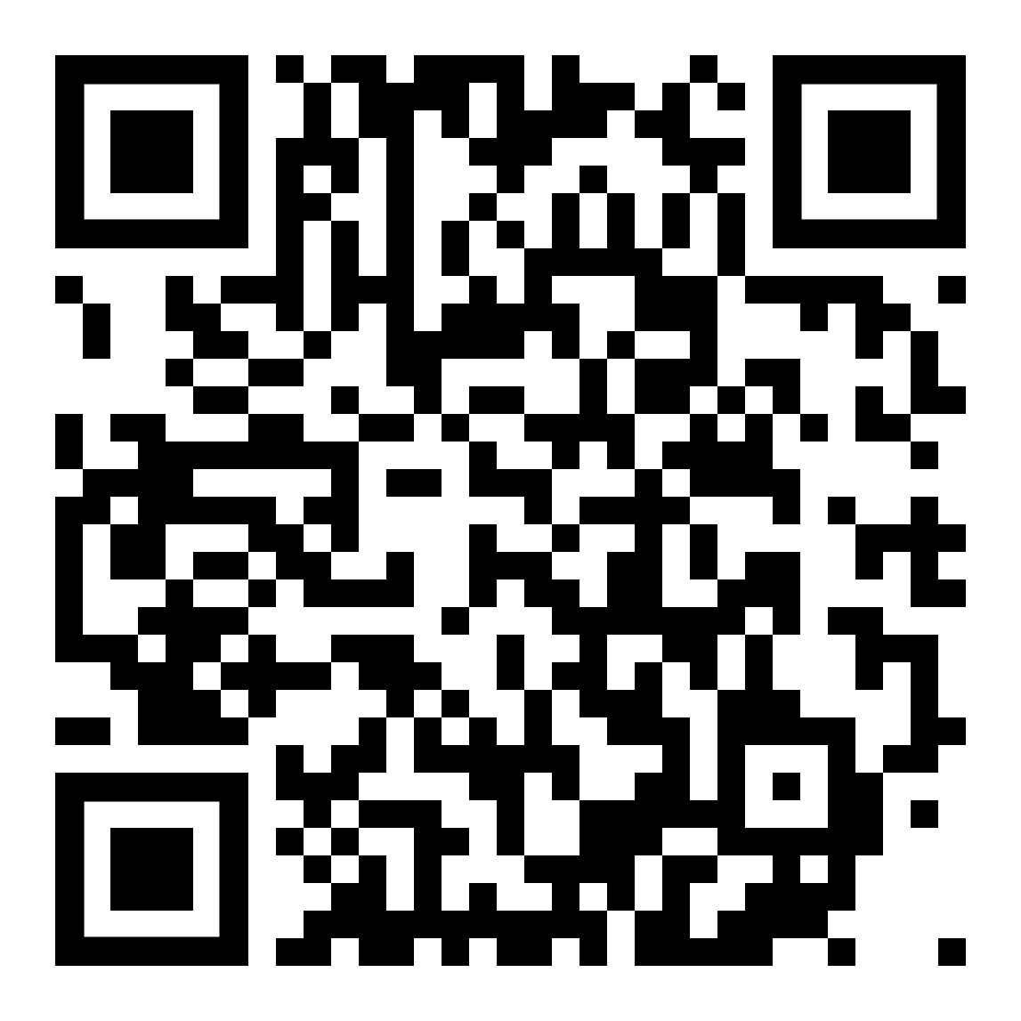 | St. Michael's School (Alden St and Miln St)
19 | 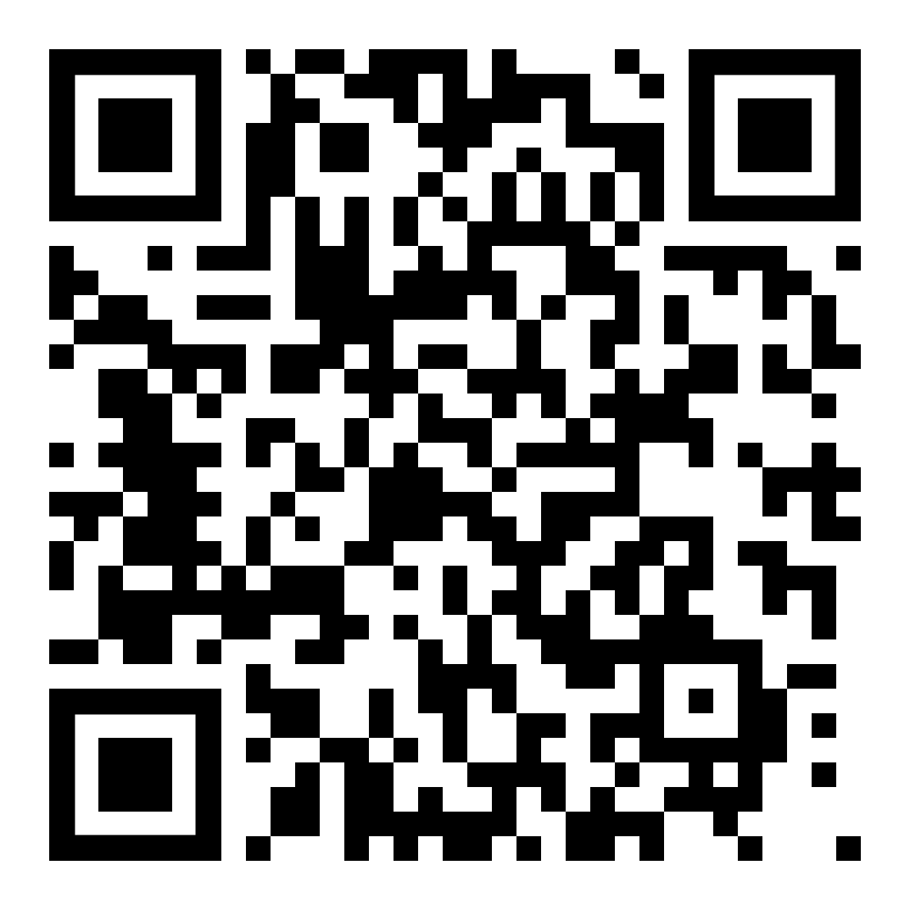 | UCC Campus and the Sperry Observatory (1033 Springfield Ave)
20 | 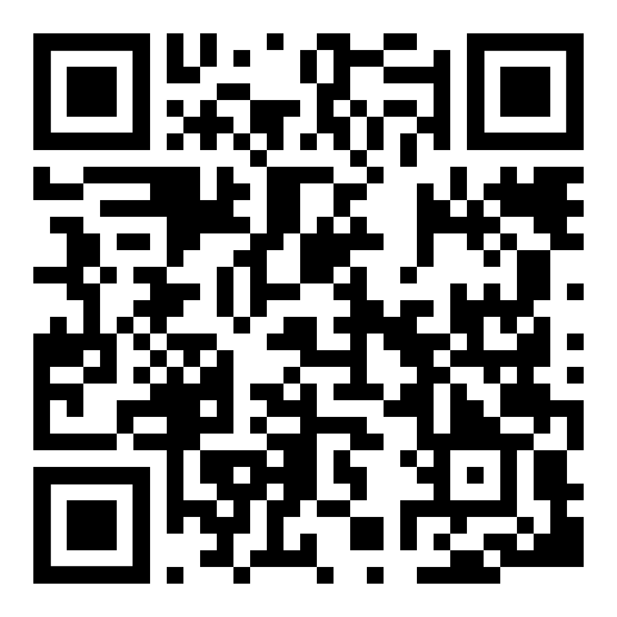 | Street Signs
21 | 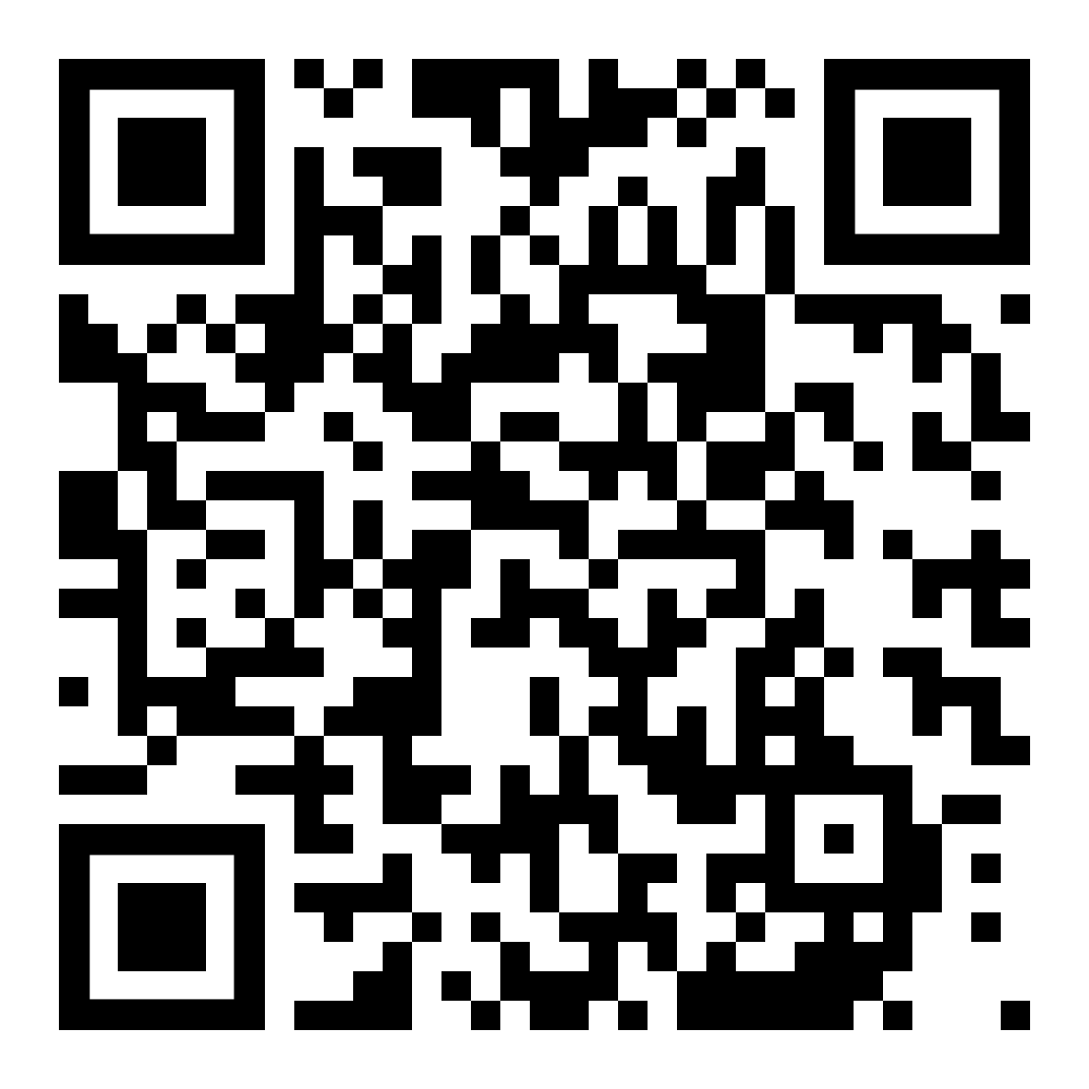 | Culin House (215 Holly St)
22 | 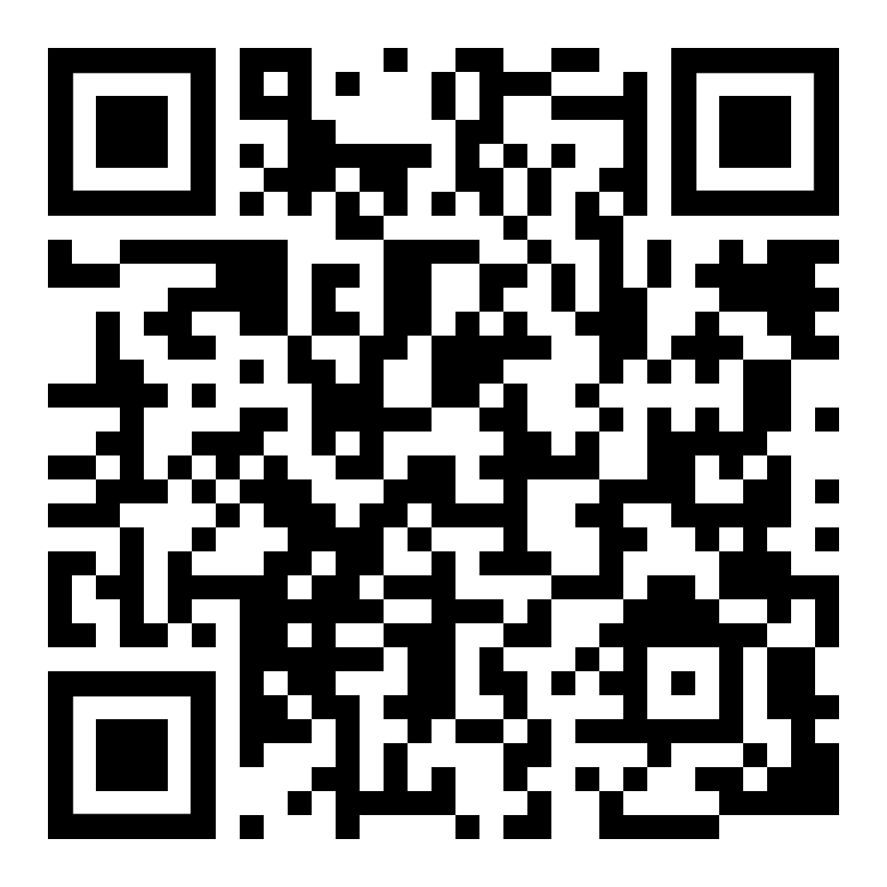 | Hanson House (38 Springfield Ave)
23 | 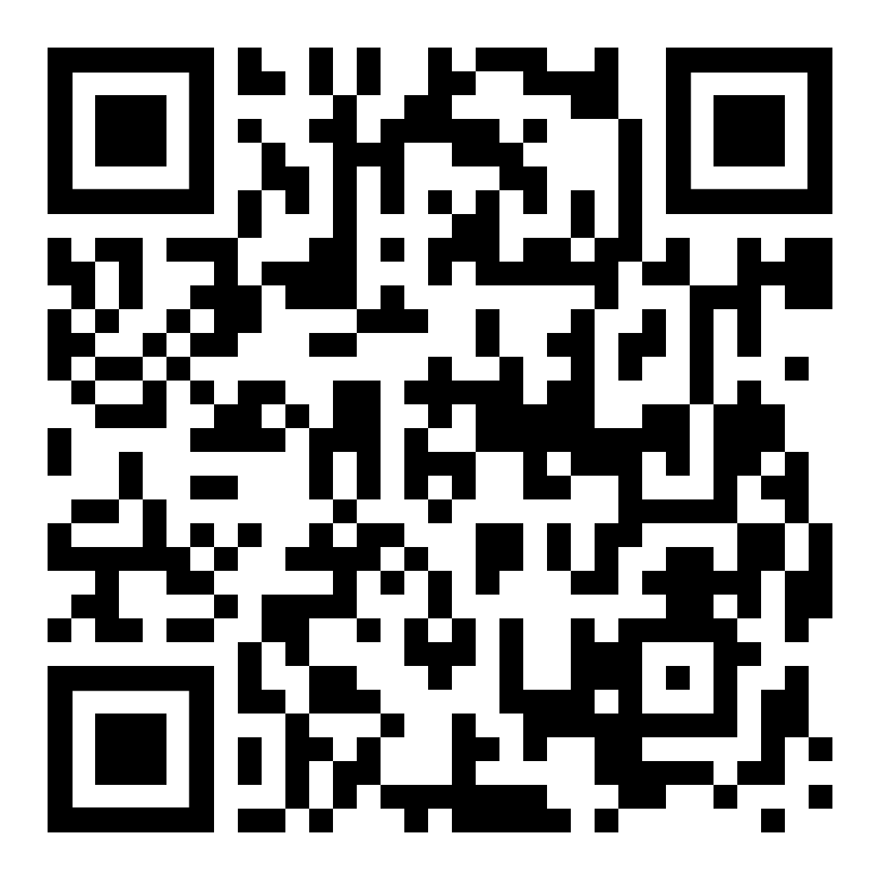 | Hampton Park (Hampton St and Eastman St)
24 | 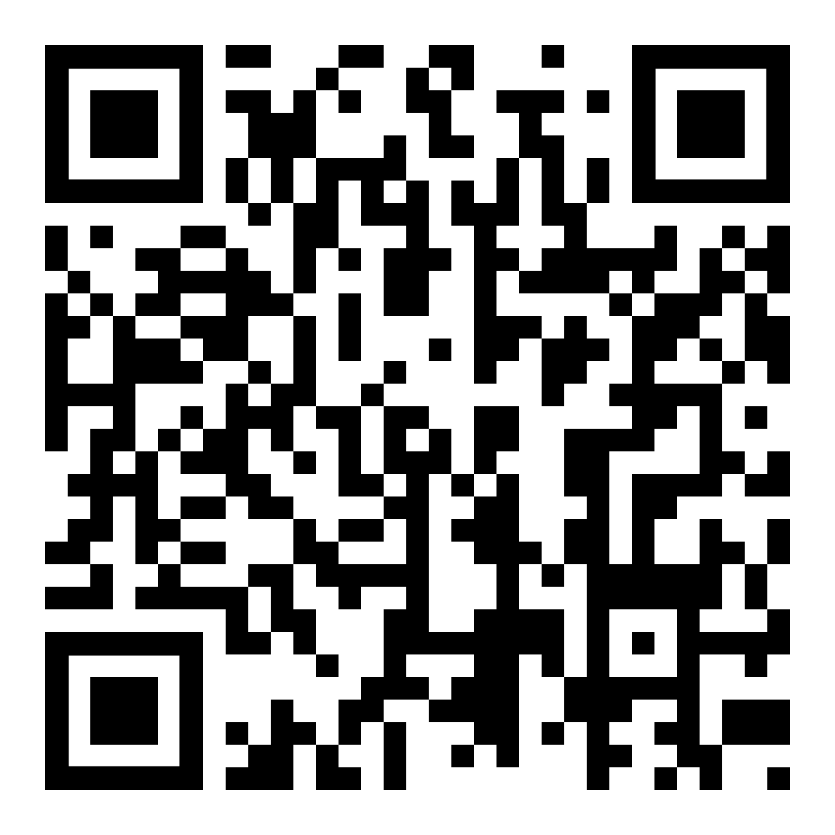 | English Village (Prospect Ave and Claremont Pl)
25 | 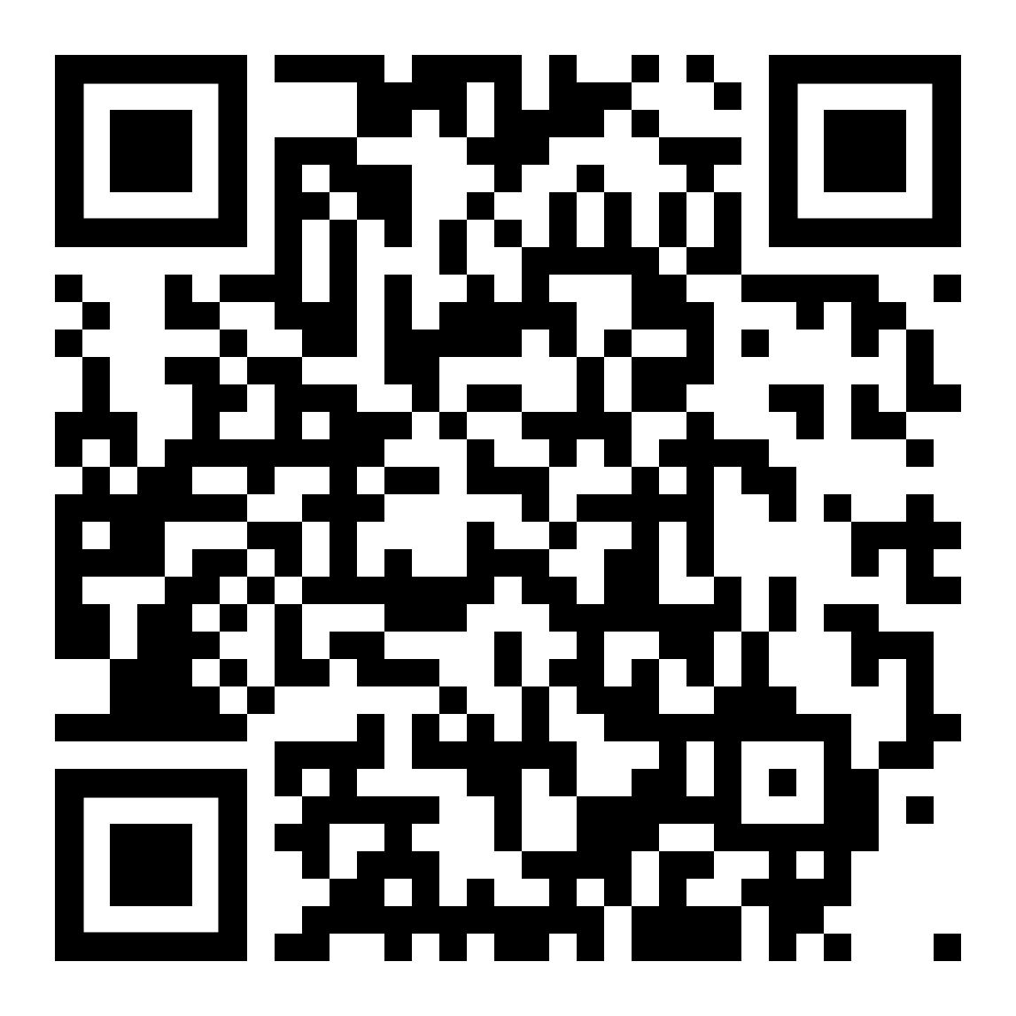 | Trinity Episcopal Church ( 205 North Avenue E )

