Cranford Historic Preservation Advisory Board
38 Springfield Avenue
Cranford, NJ 07016
Cranford Historic Preservation Advisory Board
8 Springfield Avenue
Cranford, NJ 07016

Map of Cranford’s Development

I would like to purchase a copy of the Map of Cranford’s Development

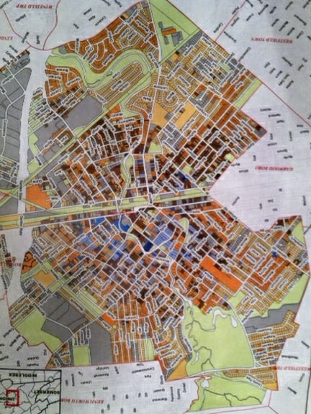

NAME _____________________________________________________________________

ADDRESS __________________________________________________________________

EMAIL _____________________________________________________________________

PHONE ____________________________________________________________________

MAP PAPER COLOR PREFERENCE ___ WHITE ___ OFF WHITE

Please send this form along with a $10 check payable to Cranford Historic Preservation Advisory Board (HPAB) to: HPAB, 8 Springfield Ave, Cranford, NJ 07016

Visit our website at www.preservecranford.com or email us at preservecranford@yahoo.com

